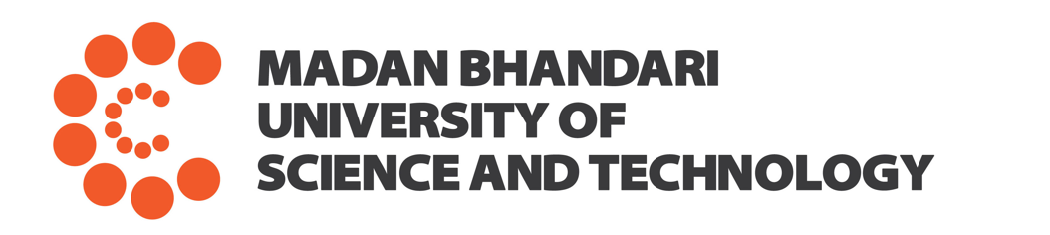

Acceptance of Applicants to the PhD and Master of Applied Science Programs (Second Call)
August 27, 2025

The following candidates, who applied to the PhD and Master of Applied Science (MAS) programs at Madan Bhandari University of Science and Technology by August 9, 2025, and participated in the written examinations and interviews on August 22-24, have been selected for admission to their respective programs.

Program: Artificial Intelligence | Level: PhD
None selected.
Program: Sustainable and Resilient Infrastructure | Level: PhD
None selected.
Program: Organic Agriculture | Level: Master of Applied Science
Rank | Name of Candidates | Financial Support
1 | Rukshana Thapa | 50% tuition fee waiver
2 | Anish Raj Dahal | 25% tuition fee waiver
3 | Lokendra Raj Basnet | 25% tuition fee waiver
Program: Sustainable and Resilient Infrastructure | Level: Master of Applied Science
Rank | Name of Candidates | Financial Support
1 | Aayush Niraula | 100% tuition fee waiver
The last date for the admission of the selected candidates is September 2, 2025 (4 pm).
Candidates selected in earlier admission cycles who missed the deadline may still be considered upon request and until the seats are available. Financial support, if any, will depend on availability at the time of admission, and any previous offer will no longer be valid.

Requirements for admission
- Submission of Admission Form, available at the website, duly filled electronically with photo
- Migration Certificate
- Bank voucher/evidence of the deposition of the following fees and deposits:
  - Registration Fee: NRs. 25,000
  - Refundable Deposit: NRs. 50,000 (Refundable after completion of studies)
  - Refundable security deposit: NRs. 25,000 (towards the compensation of possible damages to the University property associated with negligence).
Bank details to deposit fees and deposits
Madan Bhandari University of Science and Technology
A/C No. 01800106701870000001
Nepal Bank Limited
Gabahal Branch, Lalitpur

Important dates
Orientation, course registration and start of instruction: November 23, 2025 at 11am.

Transportation
Students may use the University bus, which departs from Pulchowk Campus at 8:15 am. The bus is free of charge for the first day. The information on charges for using bus on other days will be provided during orientation.

For Inquiries
Email info@mbust.edu.np or call +977-9851119749 (Binod Adhikari).


Kirti Kusum Joshi, PhD
Director
Institute of Applied Sciences

